Name : Vishal Jha

Batch : Data Engineering

Date : 25-01-2024

Topic : SQL Coding Challenge (Joins)

1. Created and Use database CodingChallenge1.

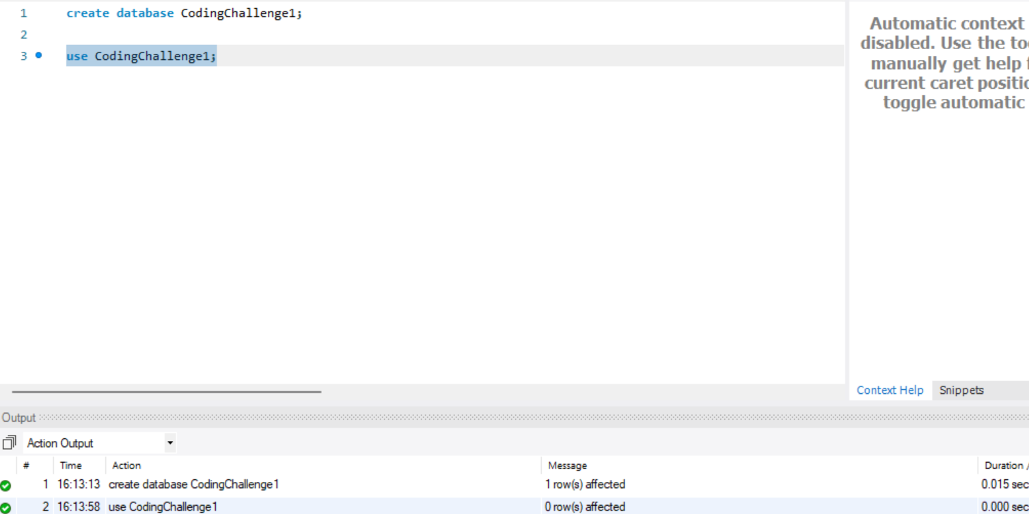

1. Created Table Customers and inserted some values.

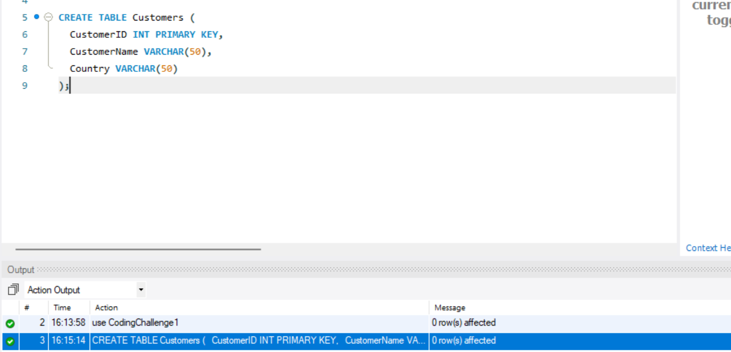

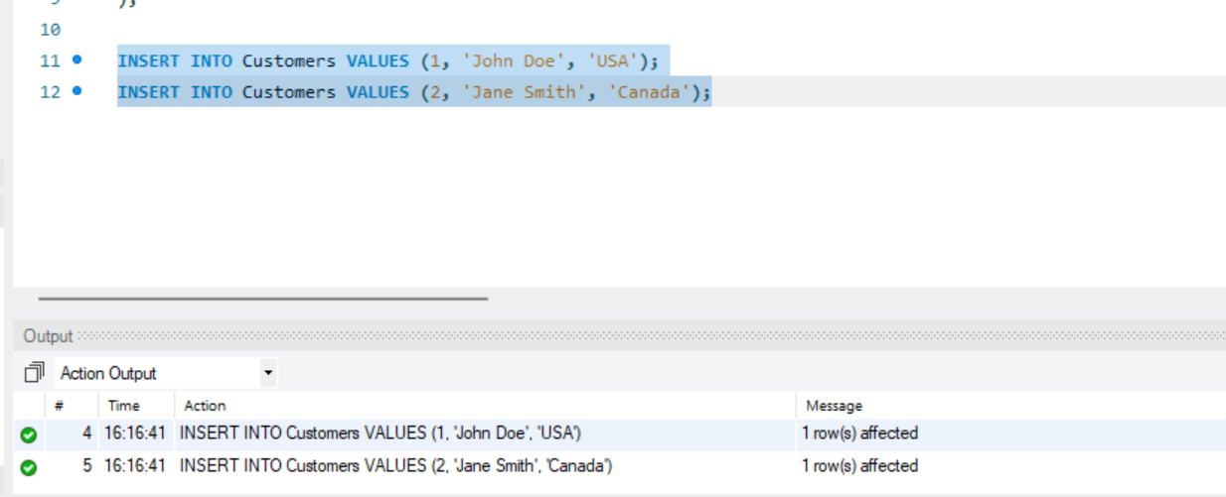

1. Created another table Orders and inserted some sample data.

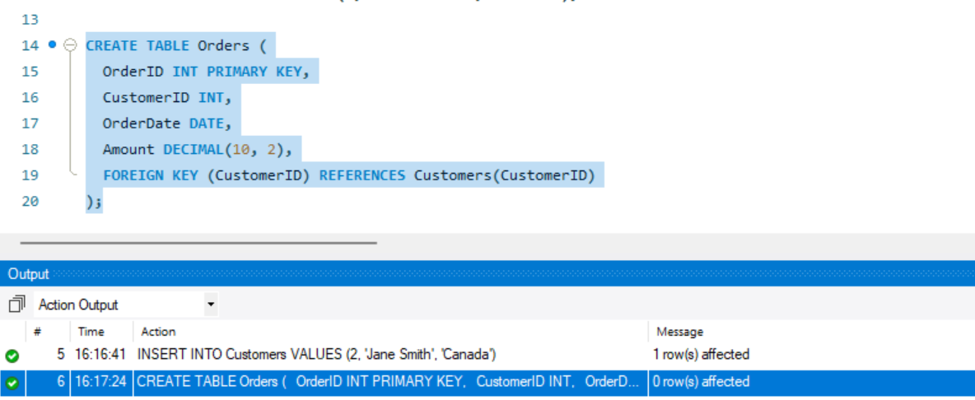

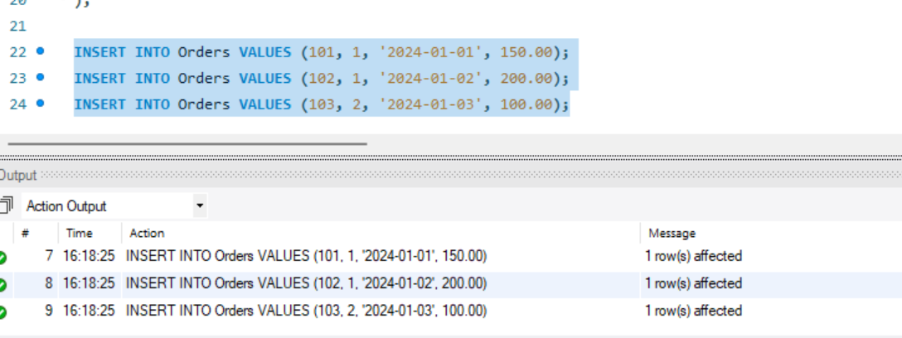

1. Inner-Join- Returns records that have matching values in both tables.

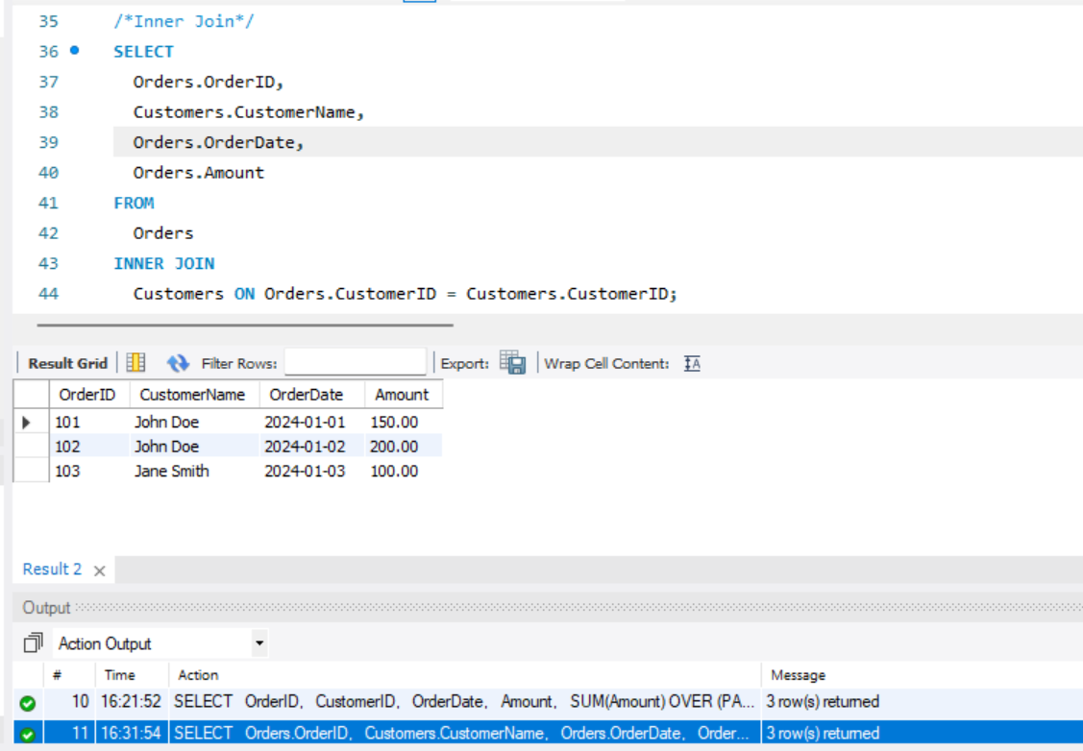

1. Left Join - Returns all records from the left table, and the matched records from the right table.

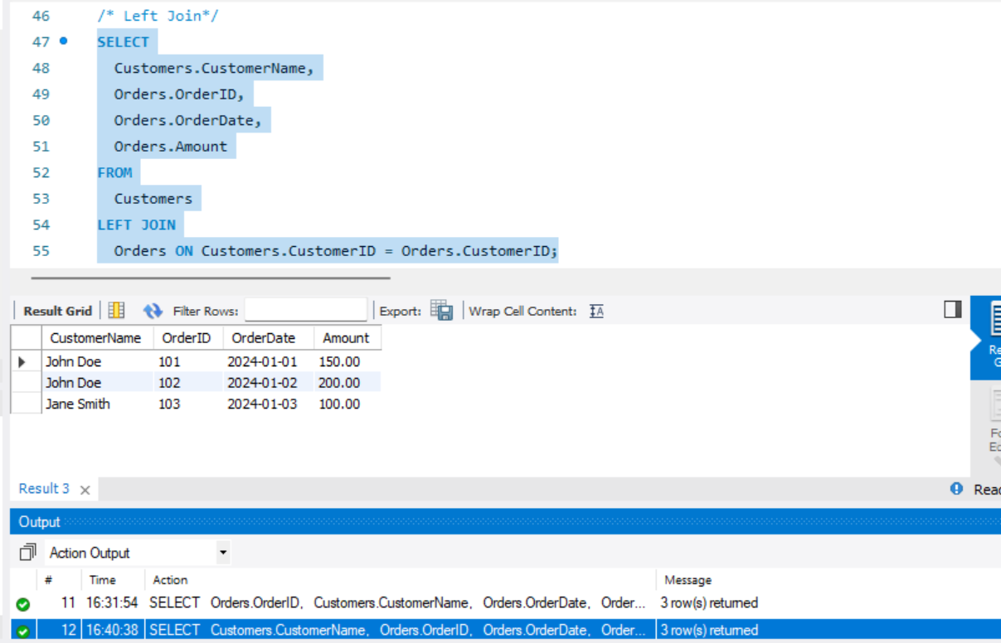

1. Right Join - Returns all records from the right table, and the matched records from the left table.

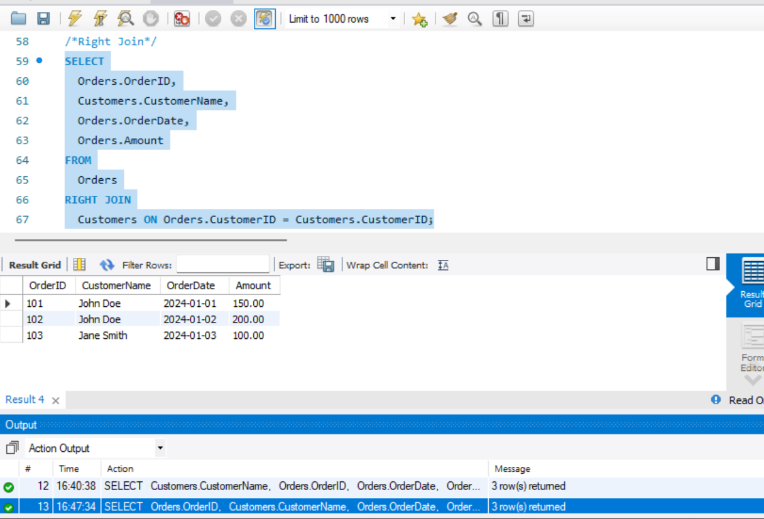

1. Cross Join - Returns all records from both tables.

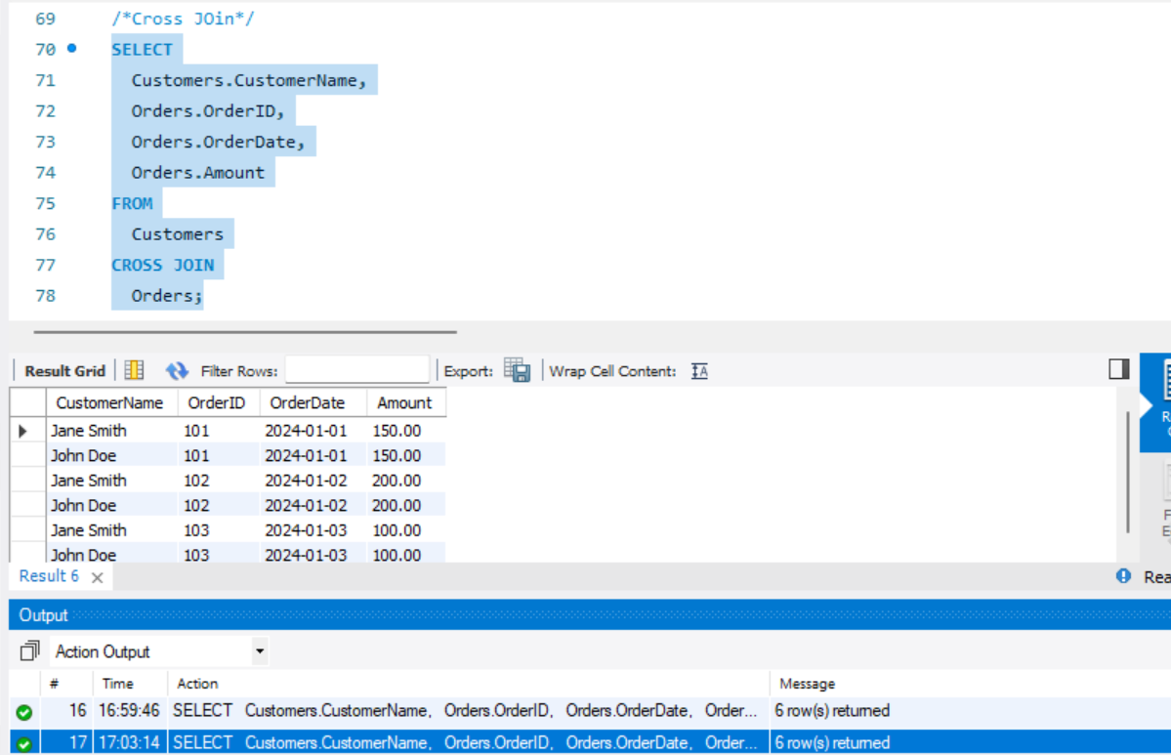

1. Self-Join.

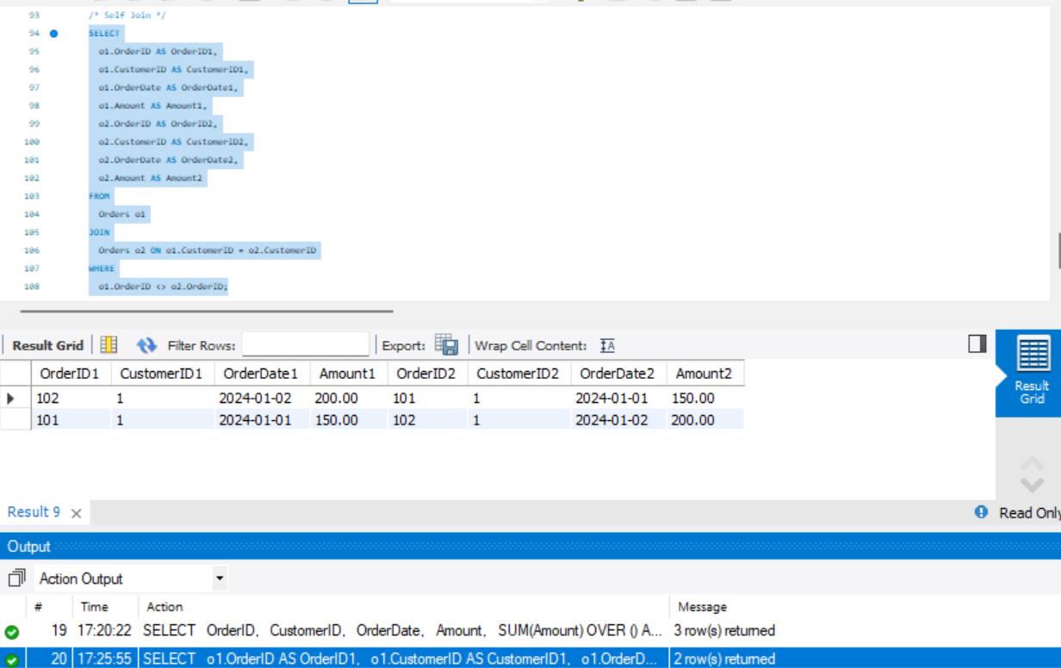

1. Full Outer Join.

